**GIT CLONE**

Repository URL

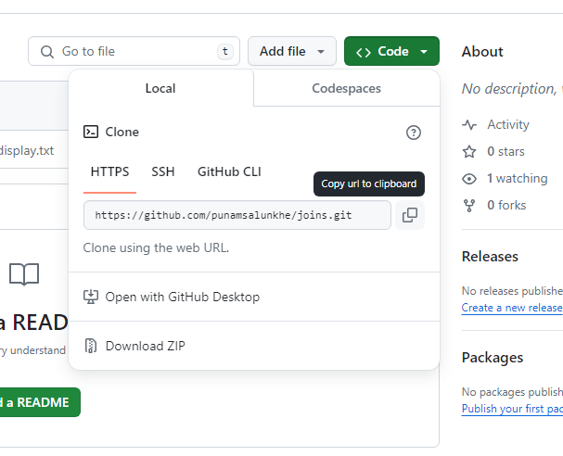

**GIT CLONE**

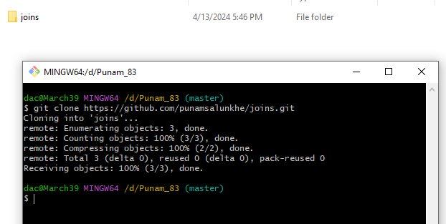

**GIT PUSH-(From local Repository to Remote Repository)**

1)git status

2)git add . or we can write git add <filename>

3) git status

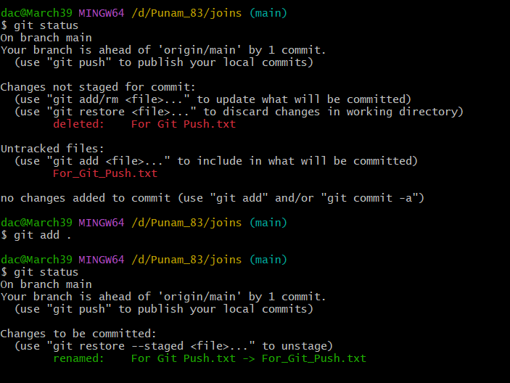

4) git commit -m "For git Push file added"

5)git config --global user.name “enter user name of git repo”

6)git config --global user.email enter user email

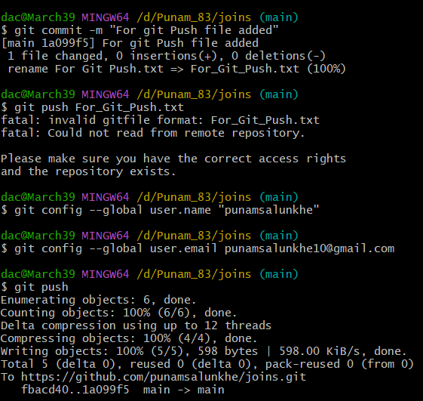

7)git push or git push <file name>

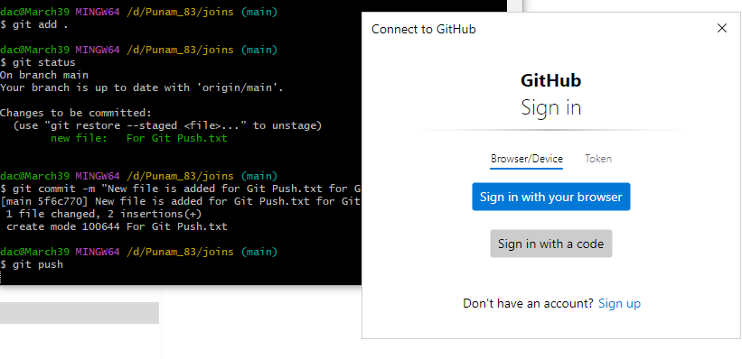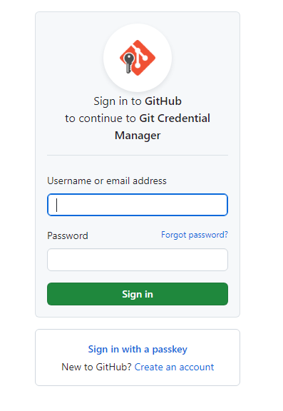

Or you can use token to give access

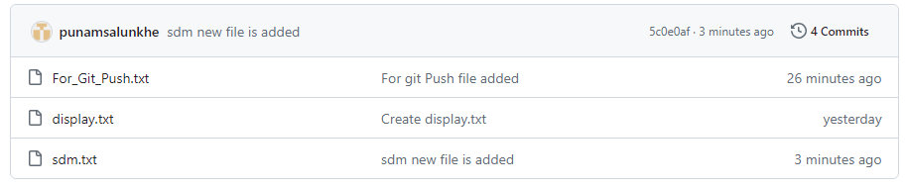

**GIT PULL – (Incorporates changes from a remote repository into the current branch)**

**Original main branch**

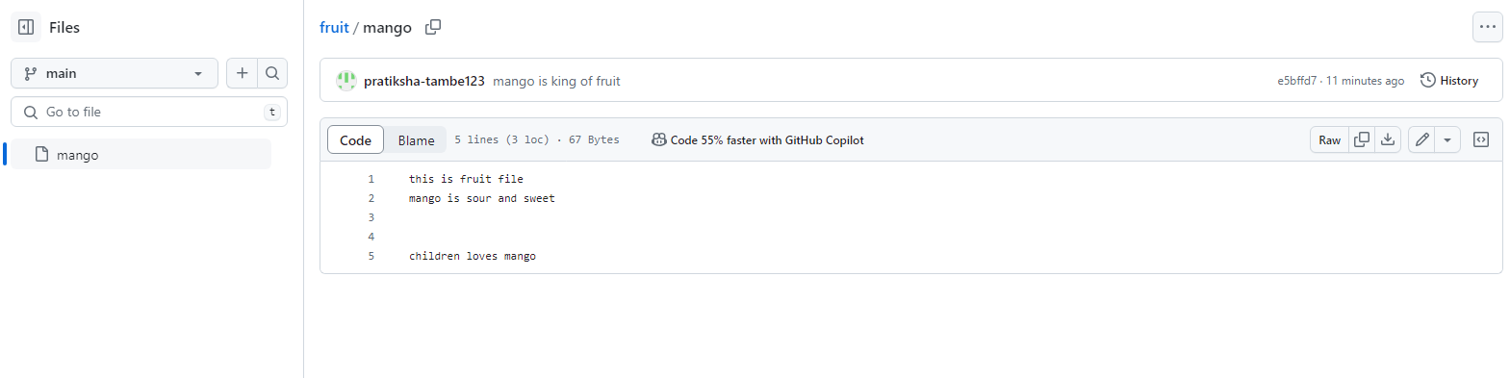

**Changed main branch**

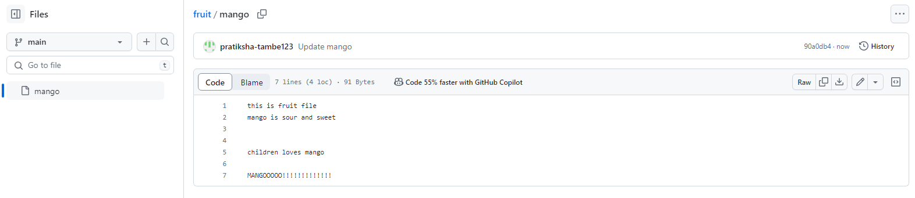

**After Git pull**

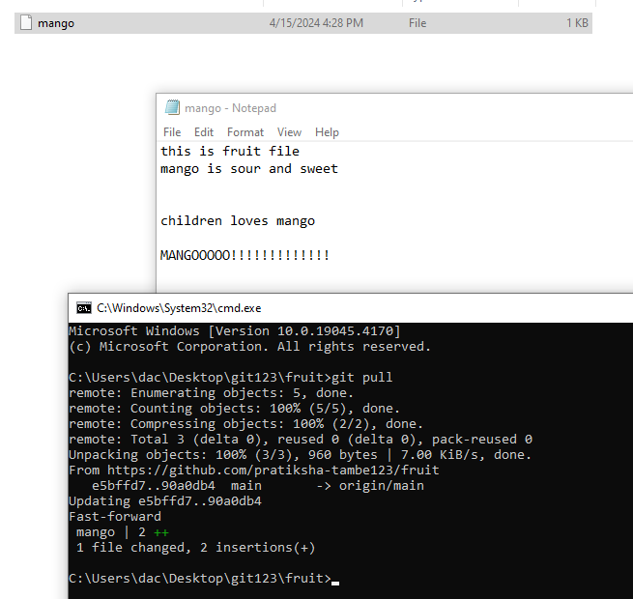

**GIT MERGE, GIT BRANCH**

Microsoft Windows [Version 10.0.19045.4170]

(c) Microsoft Corporation. All rights reserved.

C:\Users\dac\Desktop\git123\fruit>git status

On branch main

Your branch is up to date with 'origin/main'.

Changes not staged for commit:

(use "git add <file>..." to update what will be committed)

(use "git restore <file>..." to discard changes in working directory)

modified: mango

no changes added to commit (use "git add" and/or "git commit -a")

C:\Users\dac\Desktop\git123\fruit>git add .

C:\Users\dac\Desktop\git123\fruit>git status

On branch main

Your branch is up to date with 'origin/main'.

Changes to be committed:

(use "git restore --staged <file>..." to unstage)

modified: mango

C:\Users\dac\Desktop\git123\fruit>git commit -a -m "mango is added in file"

[main 227ae4e] mango is added in file

1 file changed, 1 insertion(+)

C:\Users\dac\Desktop\git123\fruit>git push

Enumerating objects: 5, done.

Counting objects: 100% (5/5), done.

Writing objects: 100% (3/3), 289 bytes | 289.00 KiB/s, done.

Total 3 (delta 0), reused 0 (delta 0), pack-reused 0 (from 0)

To https://github.com/pratiksha-tambe123/fruit.git

85e5117..227ae4e main -> main

C:\Users\dac\Desktop\git123\fruit>git branch

* main

C:\Users\dac\Desktop\git123\fruit>git branch mangobranch

C:\Users\dac\Desktop\git123\fruit>git branch

* main

mangobranch

C:\Users\dac\Desktop\git123\fruit>git checkout mangobranch

Switched to branch 'mangobranch'

C:\Users\dac\Desktop\git123\fruit>git branch

main

* mangobranch

C:\Users\dac\Desktop\git123\fruit>git status

On branch mangobranch

Changes not staged for commit:

(use "git add <file>..." to update what will be committed)

(use "git restore <file>..." to discard changes in working directory)

modified: mango

no changes added to commit (use "git add" and/or "git commit -a")

C:\Users\dac\Desktop\git123\fruit>git add .

C:\Users\dac\Desktop\git123\fruit>git status

On branch mangobranch

Changes to be committed:

(use "git restore --staged <file>..." to unstage)

modified: mango

C:\Users\dac\Desktop\git123\fruit>git commit -a -m "mango is king of fruit"

[mangobranch e5bffd7] mango is king of fruit

1 file changed, 3 insertions(+)

C:\Users\dac\Desktop\git123\fruit>git push

fatal: The current branch mangobranch has no upstream branch.

To push the current branch and set the remote as upstream, use

git push --set-upstream origin mangobranch

To have this happen automatically for branches without a tracking

upstream, see 'push.autoSetupRemote' in 'git help config'.

C:\Users\dac\Desktop\git123\fruit>git push origin mangobranch

Enumerating objects: 5, done.

Counting objects: 100% (5/5), done.

Delta compression using up to 12 threads

Compressing objects: 100% (2/2), done.

Writing objects: 100% (3/3), 310 bytes | 310.00 KiB/s, done.

Total 3 (delta 0), reused 0 (delta 0), pack-reused 0 (from 0)

remote:

remote: Create a pull request for 'mangobranch' on GitHub by visiting:

remote: https://github.com/pratiksha-tambe123/fruit/pull/new/mangobranch

remote:

To https://github.com/pratiksha-tambe123/fruit.git

* [new branch] mangobranch -> mangobranch

C:\Users\dac\Desktop\git123\fruit>git branch

main

* mangobranch

C:\Users\dac\Desktop\git123\fruit>git checkout main

Switched to branch 'main'

Your branch is up to date with 'origin/main'.

C:\Users\dac\Desktop\git123\fruit>git branch

* main

mangobranch

C:\Users\dac\Desktop\git123\fruit>git merge mangobranch

Updating 227ae4e..e5bffd7

Fast-forward

mango | 3 +++

1 file changed, 3 insertions(+)

C:\Users\dac\Desktop\git123\fruit>git push origin main

Total 0 (delta 0), reused 0 (delta 0), pack-reused 0 (from 0)

To https://github.com/pratiksha-tambe123/fruit.git

227ae4e..e5bffd7 main -> main

C:\Users\dac\Desktop\git123\fruit>

